Sustainable Energy Concept in a Municipality

Lukás Juza (Czech Republic)
Silvia Marhold (Austria)

Co-operating Universities



Financial support by

Prague and Vienna, 2010

Content

1. Problem Statement 3
2. Motivation 3
3. The Model of Güssing 4
Initial Situation 4
Implementation of Sustainable Energy Concept 5
Technical Point of View 7
Impacts on the Region 9
Challenges 11
4. Using the Model in the Czech Republic 12
5. Conclusion 17
6. Index of Figures 18
7. Index of Table 18
8. References 19

1. Problem Statement
The world's energy system is unsustainable at all points of its three aspects - economy, environment and social dimension. At present the primary energy supply of the world and in particular of the developed countries is characterized by a large share of fossil fuels, such as oil, coal and natural gas. Due to the high usage of these energy sources and consequently dependency on them humans will face several problems in the future. First of all, fossil fuels are non-renewable and thus limited. The depletion of the resource will lead to a decline of energy production based on fossil fuels and finally to an exhaustion of the resource. Furthermore, during the combustion of fossil fuels greenhouse-gases such as carbon dioxide, methane, and nitrogen oxides are released, which contribute to global warming. The energy sector accounts for two-third of current greenhouse-gas emissions and consequently plays an important role in climate discussions. Another problem is the energy security risk. There exists a high dependency on imports of fossil fuels from volatile countries or regions. Consequently, nowadays humanity is facing major challenges which have to be solved. One the one hand the supply of reliable and affordable energy has been secured and on the other hand the offered energy has to be produced in a sustainable way. (OECD/IEA 2008: 3)

2. Motivation
As our current energy supply is problematic it forces us to think about alternative ways of energy production. On a smaller scale a possible solution could be a sustainable energy concept, which is based on regional renewable resources. Such an innovative energy concept was developed in Güssing, Austria in 1990. The objective of the concept was to abandon completely fossil energy and to supply the town and subsequently the whole district with energy. The model comprises the aspects heat generation, fuels, and electric power. Currently the town has achieved to be energy self-sufficient and the local biomass plant produces more energy than is consumed on an annual basis. Moreover, the former poor region gains an added value of EUR 13 million annually. (EEE 2007: 2)
The paper aims to describe the implementation process of a sustainable energy concept and identify the motivation and the challenges of such a process using the example of the Güssing model. Furthermore, we endeavor to realize the first steps of a possible implementation in the Czech Republic. On the one hand we will examine both the energy supply and consumption. On the other hand we will have a look on the availability of renewable resources in the Czech Republic.
Finally, we will draw conclusion if such a project is feasible in the Czech Republic and reflect our results. Our approach of this paper will be to review academic papers such as realize investigations in the Internet. Finally, we attempt to arrange to talk to an expert of Güssing.

3. The Model of Güssing

Initial Situation
Twenty years ago a small town in the south of Burgenland in Austria decided to develop the ambitious idea to avert completely the use of fossil energy and to supply the town with energy based on regional renewable resources. (Koch et al. 2006: 18) The small city, with a cadastral area of 49.28 km², is called Güssing and has a population of approximately 3,800 people in 2009. (Statistik Austria 2009a) Güssing is also the capital of the same named district of about 26,600 inhabitants in 2009. (Statistik Austria 2009b) The starting signal for the project “energy-self-sufficient city Güssing” was given in 1990 by the decision of the municipal council to phase out completely the fossil energy supply. (EEE 2007: 2)
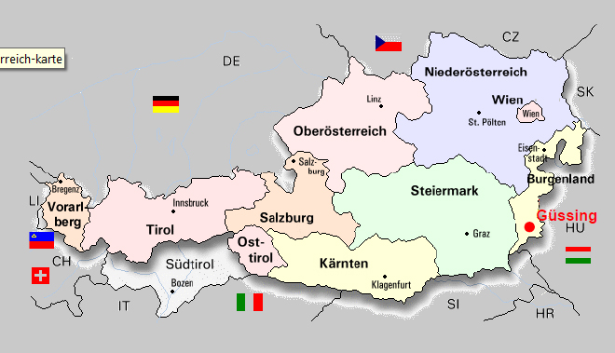
Figure 1: Austria
Source: Koch et al. 2007
The motivation to realize the challenging project aroused from the poor economic situation and the peripheral location of the district. By then, Güssing was one of the poorest regions in Austria. The geographically disadvantageous location close to the Hungarian border (the iron curtain did not fell until 1989) inhibited major trade and also industrial business did not exist then. Another central problem was the lack of an adequate transportation infrastructure in the entire district. The consequence was an insufficient offer of jobs and subsequently, a high migration rate and a considerable number of commuters formed a problem for the municipality. The unemployment rate was up to 28 – 30 % and 70 % of the working population commuted every week to the cities of Vienna and Graz. (ATV 2009, EEE 2007: 2) Due to energy import the district had to fight additionally capital outflow from the region. Güssing had to pay annually € 6.2 million for oil, power and fuels while existing local resources kept mostly unused or even neglected. The share of forest in the region accounts for 45 %. (Koch et al. 2006: 18, EEE 2007: 2, Fencl 2004, Keglovits 2010a)

Implementation of Sustainable Energy Concept
The ecological showcase was developed significantly by Reinhard Koch. The former engineer for the municipality and now CEO of various regional companies and Peter Vadasz, mayor of Güssing, convinced the municipal council to implement the Güssing model. Thus, the project team consisted of Reinhard Koch and the local government. Conjointly they established the concept step by step embracing the aspects heat generation, fuels, and electric power. (derStandard 2007, EEE 2007: 2) The main objective of the sustainable concept based on decentralized energy supply was to achieve in the first instance energy autarky in the town of Güssing. Subsequently, the municipality endeavored to supply the entire district with renewable energy source which can be found in the region. Along with the principle goal the local government aimed for solving the challenges of the region as stated initially and to provide the district “with new forms of added value”. (EEE 2007: 2) To realize the plan, various steps had to be taken, which will be described subsequently.
The first step towards the implementation of the concept comprised the evaluation of the energy demand and the detection of potentials to optimize the energy use in Güssing. Among the measures to cut the energy demand were the replacement of old windows, the reconstruction of heating systems, the installation of a more efficient street lightening, and the improvement of the heat insulation. As a result of the energy saving measures of all buildings in the town center, expenses on energy were decreased by almost 50 %. Subsequently, by means of brain storming all regional resources were identified and in regard to their sustainability analyzed. (Brunner 2004: 32, EEE n.d. a: 3) The examination of the energy demand and locally available resources was an important step in order to know how much energy has to be provided and what kind of technologies should be applied. Consequently, the municipality knew how much money was needed to realize the project. Moreover, along with the examination further questions had to come into consideration in this stage of the implementation process. First of all it is important to know, how the space partition of the region is. More precisely, the municipality had to investigate how large the area of arable land and forest is and how it is used in order to know how much area is available to supply sufficient sources. Furthermore, the question was raised how the ownership of this land is structured and finally, how can the provision of the resources be assured contractually. (Koch et al. 2006: 14, EEE n.d. b: 3) In the case of the city of Güssing, rapeseed and wood were identified as the major renewable energy resources for the energy concept. As at this time wood was the one of the most important input for energy generation, the forest association of Burgenland (Burgenländischer Waldverband) was the central partner of the project regarding supplier of raw materials, logistics, and price guarantee. (Brunner 2004: 33)
Based on the first step, the project team started to seek for sources of finance and public support for the planned power plants. The Republic of Austria (due to the law of green electricity - ökoStrom Gesetz) and the state Burgenland acted as sponsors. Later on the European Union also served as a grantor. The reason was that by the accession of Austria to the European Union in 1995, Burgenland was recognized as a region covered by Objective One and thus, was granted structural funds support from the European Community. (EEE n.d. a: 8, Brunner 2004: 33)
Then, in 1991 the first plant in Güssing went on stream in order to implement the energy concept. The company Burgenländische Alternativ-, Treib- und Heizstofferzeugung constructed an oil mill to process oilseeds and produce methyl ester based on rape oil (more commonly known as agrodiesel or biodiesel). The investment cost amounted to approximately € 3.3 million. The installation of the site brought four new jobs to the region. However, due to the disadvantageous legal developments the site just produces cooking oil at the moment. (Brunner 2004: 42, Rotter 2009)
After the successful realization of two small-scale biomass heating systems, in 1996 the first biomass district heating plant in the region was constructed. The forest association, the municipality, the local energy supply company and Reinhard Koch acted as the shareholder of the district heating plant, which required investment cost of € 13 million. The biomass needed for the site has been bought from local and regional forest owners and has been supplied by the forest association for the most part. (Brunner 2004: 33, 38-39) Later on, the two parquet manufacturers, the largest ones in Austria, were attracted by Güssing. The managers of the biomass heating system offered the companies long-term contracts guaranteeing cheap prices. In return their wooden waste was provided to the district heating plant. (Keglovits 2010a) As a result of the realization of the site CO₂ emission could be reduced and five jobs in the plant were created. Today all public buildings, more than the half of private households, and the majority of the businesses are connected to the district heating network. (Brunner 2004: 33, 38-39, Keglovits 2010a)
The installation of various demonstration energy plants in Güssing and in the region promoted gradually the realization of the concept. Beside the mentioned sites, also a photovoltaic and solar energy plant and a second district heating station were built. (EEE 2007: 2) However, it was not until the construction of the biomass power plant in 2001 that Güssing achieved to be energy self-sufficient. The following table shows the degree of self supply by comparing the energy demand in the urban area of Güssing to the supply of energy based on local resources.
Table 1: Degree of self supply of Güssing
Source: Koch et al. 2006
The biomass plant is considered not only as the exemplary site of the town, but also as the most important innovation of the Güssing model. The combined heat and power plant uses a “special fluidized bed steam gasification technology”, which was realized in Güssing for the first time. The new technology enables a decentralized energy generation and counts with high power efficiency. The investment cost amounted for € 12.4 million and eight jobs were created. The plant, which operates 8,000 hours annually, generates an electrical output of 2 megawatts and a heating output of 4.5 megawatts. The project was realized by Austrian Energy, Technical University of Vienna, EVN and Güssinger Fernwärme, whom also formed the new competence network called Bioenergy 2020+ (former Renewable Energy Network Austria). The cooperation does research and develops new technologies enabling the use of renewable resources which can be found locally. (EEE 2007: 3, RENET 2010)
As a result of the success of the model in the town, its extension to the district seemed to be obvious. The new ambitious objective was to supply the whole district with energy based on local and renewable resources. As at the first time, an analysis of the energy demand and its distribution within the region and the sectors had to be carried out again. The research considered the energy carriers used at present and the current state of renewable energy carries used in existing local heating systems. Moreover, the potential for energy saving was surveyed in the public and private sector including households and traffic. (Koch et al. 2006: 14ff)
The result of the examination showed that in principle energy autarky in a region of the size of Güssing is possible. In 2005 the calculated energy demand of the district accounted for 564,777 MWh of which existing plants cover as much as 34 % of electricity demand, 49 % of heat demand, and 47 % of fuels demand with energy based on locally available and renewable resources. (Koch et al. 2006: 68) The project participants developed five different scenarios of an energy supply based on renewable sources. Considering the potential resources and adequate technologies it resulted that “full use of the forestland would offer the largest land reserves.” In face of complete realization of the concept there would still remain 13,000 ha to 14,000 ha land reserves (depending on the scenario). That means that approximately 30 % of the district’s surface area could still be used to satisfy increased demand in the future. (EEE 2007: 5)
However, in 2008 the model of Güssing suffered a setback because of the closure of the biodiesel plant. The decentralized biodiesel production was organized legally as a rural cooperative, which was tailored to the needs of Güssing. Local farmers supplied their rapeseed to the plant, which produced for the regional needs. The concept work perfectly over several years until international fuel consumption increased steadily leading to rapeseed being subject to speculation and thus, fluctuations in price. In 2005, the Austrian regulation to add biodiesel to fuels was introduced and kindled the price war. The regulation favored large-scale power plants and resulted in the import of palm oil and rapeseed by the operators of those power plants. Consequently, the profitability of companies for local provisions like the plant in Güssing was affected by using the more expensive local rape oil. (Keglovits 2010a) In 2008 the biodiesel plant had to declare bankruptcy. Due to the closing of the site the degree of self sufficiency of the town fell from 99 % to 51 %. Now Güssing concentrates on the production of second generation agrofuels (especially from wood). With the opening of the methanisation plant Güssing in 2009 the degree self supply increased slightly to 53 %. Moreover, the production of synthetic gasoline and diesel using the Fischer-Tropsch Process will help Güssing to reduce its CO₂ emissions and to return to its path “energy autarky”. (EEE 2010, Keglovits 2010a) The table above shows the current energy demand and supply based on renewable resources in the town of Güssing.

Technical Point of View
There are 35 power plants involved in the project and table 3 and 4 summarizes the general information about the region of Güssing. The first table shows the space partition of the district of Güssing. 50 % of the area is covered with forest and 44 % are used for agriculture. Only 6 % are settlements and traffic area. As there is no data for this year available table 4 states the latest degree of self supply of the district. For simplicity reason and the closure of the biodiesel site, we will only deal with the aspects of electricity and heat. The degree of self supply of the district of Güssing for electricity and heat is almost approximately 45 % and we assume that this number is increasing.
Table 2: General Information
Source: Koch et al. 2006
Table 3: Degree of self supply of Güssing district
Source: Koch et al. 2006
Our main interest concerns the biomass power plant located in Guessing. It is a special type of the biomass power plant.
“The vital component of the plant, i.e. the fluidized bed gasifier consists of two fluidized bed systems that are connected with each other. Biomass is gasified, together with steam, at a temperature of approx. 850°C in the gasifying zone. Using water vapor instead of air as gasifying medium results in a nitrogen-free, low-tar product gas with high calorific value. Part of the residual char is conveyed, by the circulating bed material (sand), which also serves as heat storing medium, to the combustion zone and is burned there. The heat transferred to the bed material is needed to maintain the gasification reactions. The flue gas is then separated and the heat contained therein is used in the district heating system. The product gas has to be cooled down and cleaned for use in the downstream gas engine. Heat recovered in the cooling process is, again, used for the district heating system. A special technology permits to recycle all residuals, which means that the gas cleaning process generates neither waste nor effluent. The gas engine converts chemical energy contained in the product gas into electricity. Again, waste heat from the engine is fed into the district heating system. This approach results in very high efficiencies: electric efficiency ranges between 25 and 28 %, overall efficiency (power and heat) is approx. 85 %.” (EEE 2007: 3)
High efficiency is achieved primarily through the combined power and heat production. The whole process can be seen on figure 2.
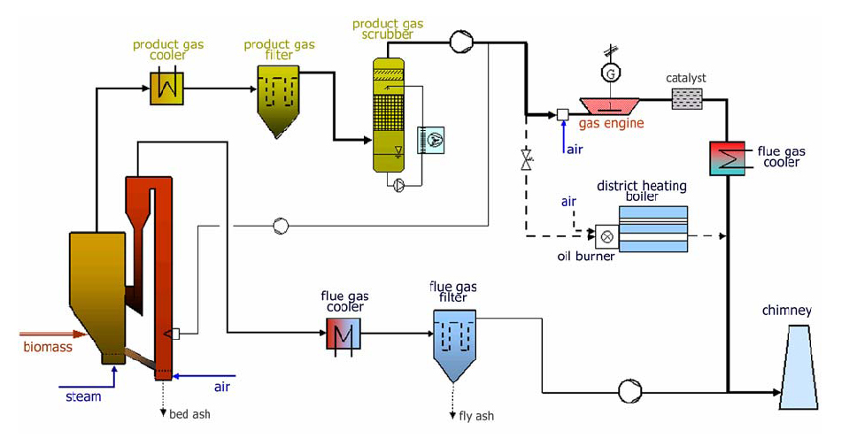Figure 2: Process of biomass power plant Güssing
Source: Energiezentrale Güssing
Main parameters of the plant:
- power capacity: 2 MW_{el}
- thermal capacity: 4,5 MW_{t}
If we assume the use of the installed capacity is 7000 hours (1 year has 8760 hours), the production of the plant accounts for MWh_{el} 14,000 and 31,500 MWh_{t} per year. This production could cover almost the entire energy needs of urban area of Guessing. It needs 25 MWh_{el} and 50.4 MWh_{t} per year. However, there exist the problem that heat and electricity have a specific property: it can only be stored to a small extent due to the accumulation of water. At all the times instant power generation has to be equal to the immediate consumption + losses. It is a fact, which many people are ignoring.

Impacts on the Region
The innovative energy concept in Güssing has not yet obtained its goal to be completely independent of fossil fuels in the whole region. However, the project has achieved notable results up to now, which were remunerated with numerous national and international awards. (EEE 2007: 2)
First of all, the city of Güssing is able to produce more electricity and heat than is used by private households and public buildings in the town. It was also able to supply the town with sufficient fuel until the unfavorable Austrian policy of subsidies forced the operators to shut down its biodiesel site. Due to the settlements of new trade business and industries Güssing cannot meet the demand of heat and electricity generated by renewable resources at the moment. Despite these setbacks, the district experiences a sustainable regional development. While in former days the municipality had to fight capital outflow in order to buy oil, power and fuels, nowadays its inhabitants spend their money on renewable energy which are supplied from local producers. Consequently, the money remains in the region. Expressed in figures, Güssing records a net income of nine million Euros each year and gains an added value of € 13 million annually. With 45 % degree of self supply the current added value of the district amounts for € 18 million. If the region realizes its energy autarky the added value will increase to € 38 million. In the face of climate change another success of the model is the reduction of its CO₂ emissions due to the realization of the sustainable energy concept. Currently, CO₂ emissions in the town account for 22,500 t each year compared to 36,995 t per year before 1995 when renewables were still not used. If Güssing achieves to abandon completely fossil fuels from their energy generation it could reduce its CO₂ emissions by approximately 85 % to 15,530 tons annually. (EEE 2010, EEE 2007: 2ff, Keglovits 2010b) The following graphic shows the development of CO₂ emissions from 1996 to 2009. The red line demonstrates the development CO₂ emissions if energy had been supplied based on fossil fuels whereas the green line illustrates the actual decrease of CO₂ emissions since 1996.
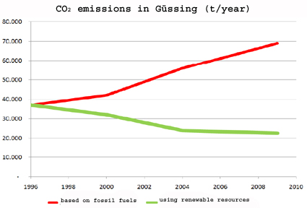Figure 3: CO2 emissions in Güssing
Source: Keglovits 2010b
Furthermore, the district could increase its attractiveness as a location for business. First of all, the municipality was able to offer cheap energy to the companies. Moreover, the establishment of the Renewable Energy Network Austria (RENET) and the European Center for Renewable Energy (EEE), the umbrella organization for all energy-related activities in Güssing, contributed to the increased attractiveness of the region. Both RENET and EEE launched numerous national and international “renewable energy” research projects drawing companies' attention to the small town in Austria. Although transport infrastructure is still poor the energy concept resulted in the settlement of fifty new enterprises in the past 20 years. The municipal tax increased correspondingly to the development. In 1993 the local tax accounted for € 340,000, whereas in 2009 the municipality earned € 1.5 million. Moreover, the realization of the decentralized local energy production created more than 1,000 direct and indirect jobs in the renewable energy sector. In addition, local farmers benefit from the decentralized energy generation. (EEE 2007: 2ff, Rotter 2009, Keglovits 2010b)
Finally, the success of the alternative energy concept of Güssing brought also a new income source for the municipality. As a lot of people are interested in the concept, tours are organized to the plants and events are held. Each year approximately 15,000 to 20,000 national and international tourists visit the town to get to know the “eco-region” and the sustainable energy concept. To cope with the stream of visitors a hotel had to be built. (Pilch 2008, Vadasz 2010)
However, there are to sides to every coin. In Güssing also occurred negative effects after the implementation of the energy concept. Citizens' initiatives are complaining about the increased environmental pollution due to the settlement of the new companies. Neighbors of local plants protest against rising exposure to noise and dust. Moreover, the purification plant is overcharged through the increased number of companies in the region. However, the capacity of the site is extended and also a soundproof wall to protect the close-by inhabitants is contemplated. (Groll 2009, diePresse 2009)

Challenges
Though Güssing was yet not able to realize its ambitious goal “energy self-sufficiency in the district of Güssing” they were able to achieve notable benefits for the region as described in the previous sub-chapter. However, in order to implement the energy concept the municipality not only had to deal with challenges in the past, but it will also face challenges regarding its energy supply in the future.
First of all, full support of the municipality is needed for realizing such a comprehensive project. Güssing recommends appointing an “energy manager”, who has the task to accompany the municipality during the development of the concept and to monitor the implementation process. Moreover, the support of the municipality enhances the acceptance of the population of such a plan. (EEE n.d. b: 2f) In the case of Güssing, as it was the mayor who endeavored to implement the sustainable energy concept support came from the highest position in the municipality. However, the population had to be convinced to support and accept in the project. Back then, petroleum was cheap and oil heating was regarded modern and progressive in contrast to use wood for heating. Numerous open councils and informative events had to organize in order to assure the population of Güssing of the advantages of district heating like the independence of oil supply, local wood delivery and thus gain of added value, no need for chimney sweeper anymore or maintenance work, and cost savings. Moreover, the construction of the biomass district heating plant required the organization of events where the public was informed. Güssing also set an example for the population by connecting all public buildings to the district heating network. Although the model of Güssing was a great success the inhabitants of Güssing are not more environmental consciousness. According to Christian Keglovits the municipal administration missed to raise more awareness to environmental problems. Just farmers and foresters are rather concerned about the topic. Keglovits also added that the perception of the development by the inhabitants differs from the outside look. (Keglovits 2010a)
However, the municipality has to face further challenges in regard to the future energy supply based on renewable resources, which are efficiency, resource allocation and policy on subsidies. Although the energy generation will not base on fossil fuels any longer efficiency will remain a major topic. Efficiency is needed to restrict energy use and thus, reduce the negative impacts on the environment, and save energy costs. Yet it will not be enough to improve only the production side, but also the consumer behavior has to be changed. If consumers will not decrease their energy demand efforts to improve energy efficiency will be outweighed. Another important aspect in the future is resource allocation. Energy generation based on biomass must not compete with food production. Therefore, responsible resource management is asked. Güssing decided to produce exactly the amount of energy based on locally available renewable resources which is needed in the region. Currently, only one third of the second growth is used. Moreover, in regard to fuel production Güssing concentrates on second generation agrofuel, which is not based on raw materials used in food industry too. Finally, the Austrian political framework challenges Güssing. In the past the regulation to add agrofuels to conventional fuel favored large-scale companies over small decentralized power plants. Moreover, obstructive regulations concerning the renewable energy sector were passed, which inhibit for example the spread of solar electricity. According to the European Center for Renewable Energy Güssing politicians have to provide incentives in order to achieve a change of mentalities towards an energy generation based on renewable resources if they want to be serious about fighting climate change. (EEE n.d. c: 2, Weitlaner 2005)

4. Using the Model in the Czech Republic
Since the model used in Güssing is quite complex involving the production of electricity, heat and fuels from renewable energy sources we must make a large number of simplifying assumptions in the next section. Above all, we will only consider the production of electricity, using waste heat for heating, and preparation of hot water. However, the production of fuels will not be taken into consideration.
We would like to apply Güssing model to similarly large area in the Czech Republic. For the next steps the location of the area is not important. Primarily we were interested in the specific demand of energy (electricity and heat) in the selected area. One of the electricity distributors in the Czech Republic provided the data concerning the consumption of electricity in an area of approximately 30,000 inhabitants. The region is characterized by many households as well as small and medium businesses. The hourly electricity consumption in the region are shown in figure 4. The date provided by PRE, a.s. are for the year 2009.
As mentioned before heat and electricity have a specific property. It can not be stored and instant power generation has to be equal to the immediate consumption + losses at all the times.

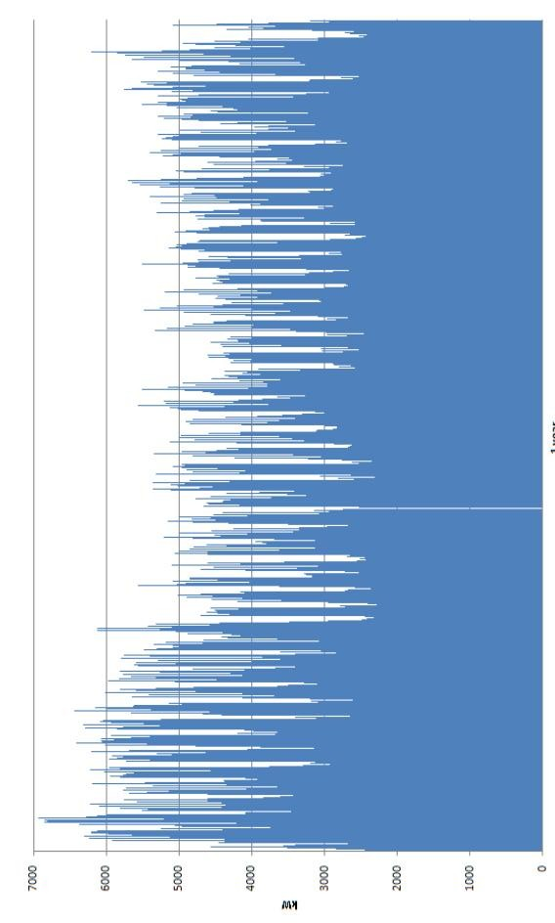Figure 4: Hourly diagram of electricity consumption in 2009
If we simply sum the hourly electricity consumption for the entire year, we get the annual electricity needs of the area. That equals approximately 30.5 TWh per year. Furthermore, we consider the simplification that there are no losses in the transport of electricity and we do not need backup of power. Figure 4 indicated, that the requirements are by no means uniform. Electricity needs better reflect Figure 5 and Figure 6. These are 2 extremes, minimum and maximum, which arise in the course of one year. Electricity generation have to be able to cover (react) these two extremes, and be continuously adjustable between them.
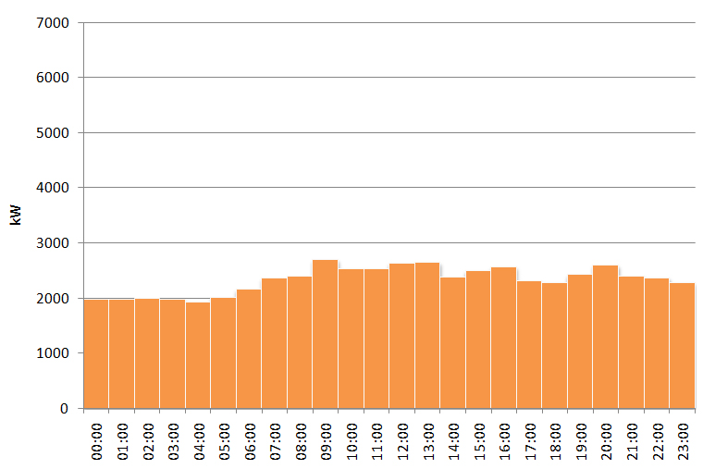Figure 5: Daily diagram of electricity consumption the date of the annual minimum
Annual minimum load is approximately 2 MW. At least this value is needed to project base power plants. Basic description and theoretical potential of some types of renewable energy in the Czech Republic will be given later. As seen from the diagram of electricity consumption on the day of the annual minimum, in addition to covering the basic load of 2 MW it is also necessary to ensure control of 0.6 to 0.7 MW to cover the daily peaks.
Annual maximum load is almost 7 MW. This is the annual maximum (logically it is in winter). On the same day, the minimum amount of electricity consumption is only 3 MW. It is necessary to cover basic load of 3 MW, but it is also necessary to have equipment, which are able to include peak and half-peak power sources to cover the additional 4 MW.
Before we begin to address the supply side of energy, it is necessary to mention that if the project will be actually realized, then discussion about energy savings have to be done. This includes the insulation of windows, wall insulation, use of efficient lamps / LED, use of heat recovery, etc. By achieving large quantities of energy savings, the total energy consumption can be decreased by almost 50 % of the total demand. However, the measures also depend on technical conditions.
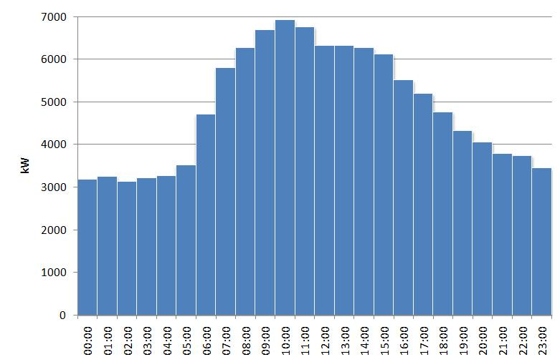Figure 6: Daily diagram of electricity consumption the date of the annual maximum
In the beginning the supply of energy was discussed, we will now look at the potentials of wind, solar and biomass of the country. Figures 7, 8 and 9 are describing the potential of wind, solar and biomass (wood chips) in the Czech Republic. For completeness, it is essential to mention that in the Czech Republic the potential of water is much smaller in comparison to Austria.
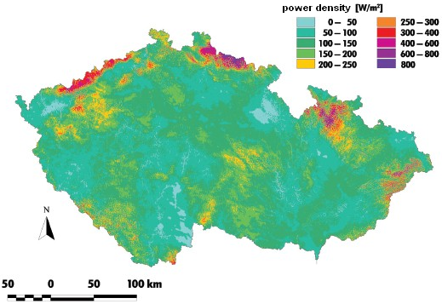Figure 7: Spatial distribution of wind power density [W/m2] - 40 m above the surface

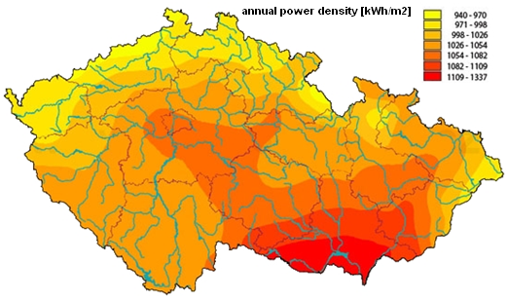Figure 8: Solar radiation map
Source: http://www.solarhaus.cz/img/mapa_slunecniho_zareni_CHMU.jpg

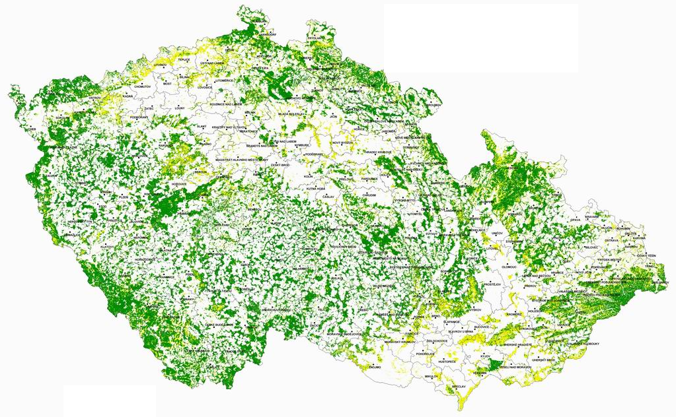Figure 9: Map of forest areas in the Czech Republic
Source: http://www.uhul.cz/prehl_map_cr

The map of spatial distribution of wind power density demonstrates that apart from some smaller regions there are not ideal conditions for the installation of wind power station. Moreover, the map of solar radiation shows that possible locations of photovoltaic panels are very limited. The share of forests is also not staggering, but we can find here some potential for growing biomass energy crops. It is also possible to exploit the potential of biogas, because there are many small agricultural cooperatives.
Now, let's go back to the energy consumption. Which energy sources can be used? Of course, suitable sites for wind and solar power plants should be used first. Both of these sources, however generates electricity only for a small part of the year. To ensure a stable electricity supply an additional source is needed. This includes biogas and biomass station. In regard to the biomass, in the Czech Republic it is preferable to use fuel based on crops rather than the fuel based on wood chips used in Austria. These two types (biomass and biogas station) of renewable energy sources can cover the base load and they can even provide energy to cover peak loads. How is it possible? Both of these types of power plants initially produce gas. Normally a biomass station does not produce gas, but in this case we are talking about biomass stations used in Güssing. The produced gas is then burned, and thus generating electricity. But it has not to been fired immediately. Such a plant could therefore produce maximum gas throughout the year and just burn the gas at times when it is needed. It would require to build power stations with gas reservoirs, where the gas is stored. What should be the capacity of the tank and what are the exact composition resources to cover the annual load diagram above? This is a very complex issue and, for example, at present, Ing. Stanislav Prucha deals the issue in his dissertation. The results will be very interesting.

5. Conclusion
Due to the unsustainable and thus problematic energy supply we are forced to think about alternative ways of energy generation. Güssing is a good example to see that energy self-supply based on locally available renewable resources and decentralized generation can be reached provided that energy saving measures are taken, resources are used and managed in a responsible and sustainable way, and also the technologies are applied reasonably. (Koch et al. 2006: 16) Moreover, the example shows that there will be setbacks which the project has to cope with. Since 2008, when biodiesel plant could not be run anymore, Güssing is not self-sufficient anymore, but instead of dismissing the energy concept the municipality decided to continue its work to return to energy autarky. The incident shows that being a self-sufficient region is a dynamic process. After the implementation of the concept it is not possible to rest on one's laurels, but continued research and constant work has to be done.
However, Güssing cannot be copied and applied to any other region in the world. Designing a sustainable energy concept means also to consider the economic and resource as well as energy related framework which vary from region to region. Every area has not only different resources available, but also different energy needs, which have to be satisfied. Depending on population figures, available area and resources as well as economic power each community has to develop its individual energy concept. (EEE n.d. b: 1) Accordingly to the mentioned aspects the model of Güssing has to be adapted in order to implement it in the Czech Republic. First of all, the energy demand was examined. That followed, the availability of renewable resources in the Czech Republic and its potentials were surveyed. Since the Czech Republic has a lower water potential than Austria it is necessary to use more biogas power plants. Due to the lower proportion of forests is also better to use crops rather than wood chips for combustion in biomass power plants.

6. Index of Figures

Figure 1: Austria 4
Figure 2: Process of biomass power plant Güssing 9
Figure 3: CO2 emissions in Güssing 10
Figure 4: Hourly diagram of electricity consumption in 2009 13
Figure 5: Daily diagram of electricity consumption the date of the annual minimum 14
Figure 6: Daily diagram of electricity consumption the date of the annual maximum 15
Figure 7: Spatial distribution of wind power density [W/m2] - 40 m above the surface 15
Figure 8: Solar radiation map 16
Figure 9: Map of forest areas in the Czech Republic 16

7. Index of Table

Table 1: Degree of self supply of Güssing 6
Table 2: General Information 8
Table 3: Degree of self supply of Güssing district 8

8. References
ATV (2009): Energiestadt Güssing. ATV Die Reportage. Available at: http://atv.at/contentset/17158/97047. Broadcasted on 23.09.2009. [Last visit: 14.05.2010].
Brunner, P. (2004): Untersuchung der Wertschöpfung und Nachhaltigkeit des Europäischen Zentrums für erneuerbare Energie für die Stadt Güssing. Unpublished diploma thesis. University of Graz, Austria.
DerStandard (2008): Zukunftsmodell Güssing. Available at: http://derstandard.at/1226396682942/Zukunftsmodell-Guessing?_seite=2&sap=2#forumstart. [Last visit: 29.04.2010].
DerStandard (2007): Energie am längeren Ast. Available at: http://derstandard.at/3120822/Energie-am-laengeren-Ast. [Last visit: 25.04.2010].
DiePresse (2009): “Energiemekka”: Die Makel des Modells Güssing. Available at: http://diepresse.com/mobil/home/panorama/klimawandel/529222. [Last visit: 01.05.2010].
European Center for Renewable Energy Güssing (EEE) (2010): Auswirkungen auf die CO2-Emissionen in Güssing. Available at: http://www.eee-info.net/cms/netautor/napro4/appl/na_professional/parse.php?mlay_id=2500&xmlval_ID_DOC[0]=1000030. [Last visit: 14.05.2010].
European Center for Renewable Energy Güssing (EEE) (2007): Model Region Güssing. Self-sufficient Energy Supply Based On Regionally Available Renewable Resources And Sustainable Regional Development. Forschungsforum 1/2007. Available at: http://www.eee-info.net/cms/netautor/napro4/appl/na_professional/parse.php?mlay_id=2500&mdoc_id=1000687. [Last visit: 27.04.2010].
European Center for Renewable Energy Güssing (EEE) (n.d. a): Informationen zu den Entwicklungen auf dem Sektor der erneuerbaren Energie in der Öko-Region Güssing. Available at: http://www.eee-info.net/cms/netautor/napro4/wrapper/media.php?id=%2C%2C%2C%2CZmlsZW5hbWU9YXJjaGl2ZSUzRCUyRjIwMDkuMDUuMDUlMkYxMjQxNTIwNzIyLnBkZiZybj1JbmZvcyUyMCVENmtvUmVnaW9uJTIwRyVGQ3NzaW5nLnBkZg%3D%3D. [Last visit: 26.04.2010].
European Center for Renewable Energy Güssing (EEE) (n.d. b): Infotext Energieentwicklungsplan. Available at: http://www.eee-info.net/cms/netautor/napro4/wrapper/media.php?id=%2C%2C%2C%2CZmlsZW5hbWU9YXJjaGl2ZSUzRCUyRjIwMDkuMDIuMTclMkYxMjM0ODgzNDQ5LnBkZiZybj1JbmZvdGV4dCUyMEVuZXJnaWVrb256ZXB0ZS5wZGY%3D. [Last visit: 26.04.2010].
European Center for Renewable Energy Güssing (EEE) (n.d. c): Häufig gestellte Journalisten-Fragen. Available at: http://www.eee-info.net/cms/netautor/napro4/wrapper/media.php?id=%2C%2C%2C%2CZmlsZW5hbWU9YXJjaGl2ZSUzRCUyRjIwMDkuMDIuMTclMkYxMjM0ODgzNDEyLnBkZiZybj1GcmFnZW5mJUZDckpvdXJuYWxpc3Rlbi5wZGY%3D. [Last visit: 26.04.2010].
Fencl, S. (2004): Güssing – Die energieautarke Stadt. Available at: http://www.oekonews.at/ index.php?mdoc_id=1006327. [Last visit: 27.04.2010].
Greenpeace (n.d.): Analyse der Rohstoffe für Biodiesel. Available at: http://www.greenpeace.at/biodiesel_inland.html. [29.04.2010].
Groll, M. (2009): Potemkins neue Heimat: Schein und Sein in der Umweltmusterstadt Güssing. Trend. Available at: http://www.trend.at/articles/0950/580/257375/potemkins-heimat-schein-sein-umweltmusterstadt-guessing. [29.04.2010].
Hofbauer, H./Rauch, R./Fürnsinn, S./Aichernig, Ch. (2006): Energiezentrale Güssing. Energiezentrale zur Umwandlung von biogenen Roh- und Reststoffen einer Region in Wärme, Strom, BioSNG und flüssige Kraftstoffe. Berichte aus Energie- und Umweltforschung 79/2006. Available at: http://www.nachhaltigwirtschaften.at/edz_pdf/ 0679_energiezentrale_guessing.pdf. [Last visit: 27.04.2010].
Keglovits, Ch. (2010a): Informationen zum Modell Güssing. Online in Internet: E-Mail von Christian Keglovits. [18.05.2010].
Keglovits, Ch. (2010b): Das Modell Güssing. Ein Beispiel für eine nachhaltige, regionale Energieversorgung. Presentation held in Güssing on 28.04.2010.
Koch, R. (2007): Energieautarker Bezirk Güssing. Ein Beispiel für eine nachhaltige Energieversorgung. Presentation for the Technical Museum of Vienna. Available at: http://www.energiesystemederzukunft.at/edz_pdf/20070920_energieregionen_der_zukunft_folien_05_koch.pdf. [Last visit: 26.04.2010].
Koch, R. et al (2006): Energieautarker Bezirk Güssing. Berichte aus Energie- und Umweltforschung 82/2006. Bundesministerium für Verkehr, Innovation und Technologie. Available at: http://www.nachhaltigwirtschaften.at/results.html/id3680. [Last visit: 27.04.2010].
Niederösterreichische Nachrichten NÖN (n.d.): Damit das Geld im Land bleibt. Available at: http://www.noen.at/redaktion/stolzbgld/article.asp?Text=184663&cat=871. [Last visit: 29.04.2010].
Organization for Economic Co-operation and Development (OECD) / International Energy Agency (IEA) (2008): World Energy Outlook 2008. Executive Summary. Paris.
oekonews.at (2009): Das Land steckt voller Energien: Energiepotenziale im ländlichen Raum sind groß. Available at: http://www.oekonews.at/index.php?mdoc_id=1041602. [29.04.2010].
Pilch, G. (2008): Güssing setzt auf erneuerbare Energie. Available at: http://www.kleinezeitung.at/steiermark/feldbach/1481813/print.do. [Last visit: 29.04.2010].
RENET (2010): Güssing Biomass-Fuelled Combined Heat and Power Plant. Available at: http://renet.at/english/sites/guessing.php. [Last visit: 05.05.2010].
Rotter, A. (2009): Güssings Energie-Konzept lockt Öko-Touristen an. Available at: http://www.wirtschaftsblatt.at/archiv/396243/index.do. [Last visit: 14.05.2010].
Statistik Austria (2009a): Interaktive Karte. Regionale Gliederungen - Gemeinden. Available at: http://www.statistik.at/web_de/statistiken/regionales/regionale_gliederungen/gemeinden/ index.html [Last visit: 27.04.2010].
Statistik Austria (2009b): Interaktive Karte. Regionale Gliederungen – Politische Bezirke. Available at: http://www.statistik.at/web_de/statistiken/regionales/regionale_gliederungen/ politische_bezirke/index.html [Last visit: 27.04.2010].
Vadasz, P. (2010): Das Modell Güssing. Ein Beispiel für eine nachhaltige Energieversorgung. Presentation held in Güssing on 10.03.2010.
Weitlaner, W. (2005): Ökostrom-Gesetz: Kahlschlag für erneuerbare Energie. Harsche Kritik von Ökostromanbietern und Energieexperten. Available at: http://pressetext.at/news/051128021/oekostrom-gesetz-kahlschlag-fuer-erneu... . [Last visit: 05.05.2010].

Burgenland is one of nine federal states in Austria, which is located in the eastern part of the country.
There were no current data available for the district.

